AI ASSISTED CODING ASSIGNMENT
Name: K.VEDHAMSH
RollNo: 2503A527O8
Batch: 24

#q1
Task: Use an AI tool to generate a Python script that stores user data (name, email, password) in a file.
Analyze: Check if the AI stores sensitive data in plain text or without encryption.
Prompt: generate a Python code that stores user data (name, email, password) in a file.
Code:
import hashlib
import json
import secrets
from pathlib import Path
DATA_FILE = Path(__file__).resolve().parents[2] / "users.json"
def hash_password(password, salt=None):
salt = salt or secrets.token_bytes(16)
password_hash = hashlib.pbkdf2_hmac(
"sha256", password.encode("utf-8"), salt, 100_000
)
return salt.hex(), password_hash.hex()
def store_user(name, email, password):
"""Store a new user's details in users.json."""
if DATA_FILE.exists():
with DATA_FILE.open("r", encoding="utf-8") as file:
users = json.load(file)
else:
users = []
if any(user.get("email") == email for user in users):
raise ValueError("A user with this email already exists.")
salt, password_hash = hash_password(password)
users.append(
{
"name": name,
"email": email,
"password_hash": password_hash,
"salt": salt,
}
)
with DATA_FILE.open("w", encoding="utf-8") as file:
json.dump(users, file, indent=2)

if __name__ == "__main__":
name = input("Enter your name: ").strip()
email = input("Enter your email: ").strip()
password = input("Enter your password: ")
try:
store_user(name, email, password)
print("User data stored successfully.")
except ValueError as error:
print(error)
output:
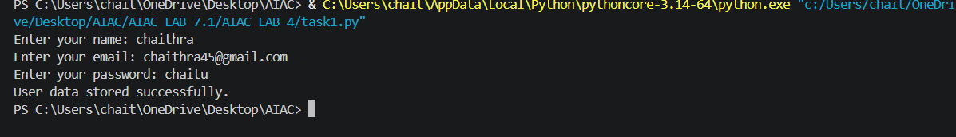
#q2
Task: Prompt an AI tool to generate a scholarship eligibility checker based on academic score, family income, and location. Examine whether the logic unfairly favors or disadvantages any group.
Prompt: generate a python code for scholarship eligibility checker based on academic score, family income, and location. Examine whether the logic unfairly favors or disadvantages any group.
Code:
from collections import defaultdict
from dataclasses import dataclass
from typing import Iterable
MIN_SCORE = 75.0
MAX_FAMILY_INCOME = 500_000.0
ACCESS_ADJUSTMENT_LOCATIONS = {"rural", "remote"}
FAIRNESS_GAP_LIMIT = 0.10
@dataclass(frozen=True)
class Applicant:
name: str
academic_score: float
family_income: float
location: str
def check_eligibility(applicant: Applicant) -> tuple[bool, list[str]]:
reasons = []
if not 0 <= applicant.academic_score <= 100:
reasons.append("academic score must be between 0 and 100")
elif applicant.academic_score < MIN_SCORE:
reasons.append(f"academic score is below {MIN_SCORE:g}")
if applicant.family_income < 0:
reasons.append("family income cannot be negative")
elif applicant.family_income > MAX_FAMILY_INCOME:
reasons.append(f"family income is above {MAX_FAMILY_INCOME:,.0f}")
if not applicant.location.strip():
reasons.append("location is required")
return not reasons, reasons
def adjusted_score(applicant: Applicant) -> float:
if applicant.location.strip().lower() in ACCESS_ADJUSTMENT_LOCATIONS:
return min(100.0, applicant.academic_score + 5.0)
return applicant.academic_score
def audit_fairness(applicants: Iterable[Applicant]) -> list[str]
applicants = list(applicants)
if not applicants:
return ["Fairness audit could not run: no applicants were provided."]

groups = defaultdict(list)
for applicant in applicants:
eligible, _ = check_eligibility(applicant)
groups[f"location:{applicant.location.strip().lower()}"].append(eligible)
income_group = "lower-income" if applicant.family_income <= MAX_FAMILY_INCOME else "higher-income"
groups[f"income:{income_group}"].append(eligible)
rates = {
group: sum(results) / len(results)
for group, results in groups.items()
if results
}
findings = ["Approval rates:"]
findings.extend(f" {group} = {rate:.0%}" for group, rate in sorted(rates.items()))

for category in ("location", "income"):
category_rates = [rate for group, rate in rates.items() if group.startswith(f"{category}:")]
if len(category_rates) > 1 and max(category_rates) - min(category_rates) > FAIRNESS_GAP_LIMIT:
findings.append(
f"Potential disparity: {category} approval rates differ by more than "
f"{FAIRNESS_GAP_LIMIT:.0%}; investigate sample size and policy impact."
)

findings.append(
"Review note: income and location may reflect unequal access to education "
"or opportunity, so this automated result should not be the sole award decision."
)
return findings
def read_applicant() -> Applicant:
"""Read and validate one applicant from the command line."""
return Applicant(
name=input("Applicant name: ").strip(),
academic_score=float(input("Academic score (0-100): ")),
family_income=float(input("Annual family income: ")),
location=input("Location (urban, rural, or remote): ").strip(),
)
if __name__ == "__main__":
try:
applicant = read_applicant()
eligible, reasons = check_eligibility(applicant)
print("\nEligible" if eligible else "\nNot eligible")
if reasons:
print("Reasons:")
for reason in reasons:
print(f"- {reason}")
print(f"Adjusted academic score for review: {adjusted_score(applicant):.1f}")
except ValueError:
print("Please enter numeric values for the academic score and family income.")
output:
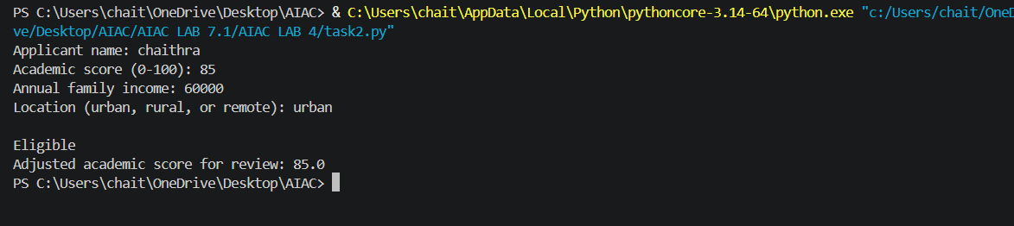
#q3
Task: Use an AI tool to generate a Python program that predicts whether a student should be selected or rejected for admission based on factors such as entrance exam score, academic marks, and other relevant admission criteria.
Analyze: Check whether the AI system provides a clear and understandable reason for its admission decision.
Prompt: generate a Python program that predicts whether a student should be selected or rejected for admission based on factors such as entrance exam score, academic marks, and other relevant admission criteria.
Code:
MIN_ENTRANCE_SCORE = 50
MIN_ACADEMIC_SCORE = 50
SELECTION_THRESHOLD = 60
def predict_admission(
entrance_score: float,
academic_score: float,
interview_score: float,
extra_curricular_score: float,
) -> tuple[str, float]:
"""Return an admission decision and the student's weighted score."""
for score in (
entrance_score,
academic_score,
interview_score,
extra_curricular_score,
):
if not 0 <= score <= 100:
raise ValueError("all scores must be between 0 and 100")
weighted_score = (
entrance_score * 0.50
+ academic_score * 0.30
+ interview_score * 0.10
+ extra_curricular_score * 0.10
)
if entrance_score < MIN_ENTRANCE_SCORE or academic_score < MIN_ACADEMIC_SCORE:
return "Rejected", weighted_score
decision = "Selected" if weighted_score >= SELECTION_THRESHOLD else "Rejected"
return decision, weighted_score
def read_score(prompt: str) -> float:
while True:
try:
score = float(input(prompt))
if 0 <= score <= 100:
return score
print("Please enter a score between 0 and 100.")
except ValueError:
print("Please enter a numeric score.")
def main() -> None:
print("Student Admission Predictor")
print("Enter scores from 0 to 100.\n")
entrance_score = read_score("Entrance exam score: ")
academic_score = read_score("Academic marks: ")
interview_score = read_score("Interview score: ")
extra_curricular_score = read_score("Extra-curricular activities score: ")
decision, weighted_score = predict_admission(
entrance_score,
academic_score,
interview_score,
extra_curricular_score,
)
print(f"\nWeighted admission score: {weighted_score:.2f}/100")
print(f"Decision: {decision}")
if __name__ == "__main__":
main()
output:
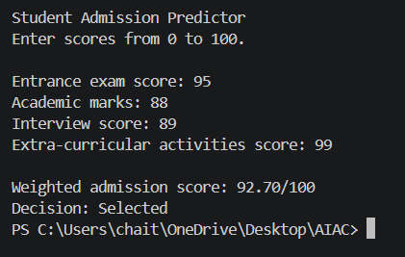
#q4
Task: Generate an employee performance evaluation system using inputs such as project completion rate, teamwork score, and attendance. Analyze the scoring logic for any unethical weighting or hidden bias.
Prompt: Generate a python code for an employee performance evaluation system using inputs such as project completion rate, teamwork score, and attendance. Analyze the scoring logic for any unethical weighting or hidden bias.
Code:
SCORE_MIN = 0.0
SCORE_MAX = 100.0
EVALUATION_THRESHOLD = 60.0
DEFAULT_WEIGHTS = {
"project_completion": 0.40,
"teamwork": 0.40,
"attendance": 0.20,
}
def validate_scores(scores: dict[str, float]) -> None:
"""Raise ValueError when a required score is missing or out of range."""
for criterion in DEFAULT_WEIGHTS:
if criterion not in scores:
raise ValueError(f"missing score: {criterion}")
if not SCORE_MIN <= scores[criterion] <= SCORE_MAX:
raise ValueError(f"{criterion} must be between 0 and 100")
def evaluate_employee(
scores: dict[str, float],
weights: dict[str, float] | None = None,
) -> tuple[float, str]:
"""Return a weighted score and decision for one employee."""
validate_scores(scores)
active_weights = weights or DEFAULT_WEIGHTS
if set(active_weights) != set(DEFAULT_WEIGHTS):
raise ValueError("weights must cover the three evaluation criteria")
if any(weight < 0 for weight in active_weights.values()):
raise ValueError("weights cannot be negative")
if abs(sum(active_weights.values()) - 1.0) > 0.0001:
raise ValueError("weights must add up to 1.0")
weighted_score = sum(
scores[criterion] * active_weights[criterion]
for criterion in active_weights
)
decision = "Meets expectations" if weighted_score >= EVALUATION_THRESHOLD else "Needs review"
return weighted_score, decision

def audit_scoring_logic(weights: dict[str, float] | None = None) -> list[str]:
"""Report weighting and measurement risks that need human review."""
active_weights = weights or DEFAULT_WEIGHTS
issues: list[str] = []
if active_weights.get("attendance", 0.0) > 0.20:
issues.append(
"Attendance has more than 20% weight; absences may reflect disability, "
"caregiving, religious observance, or approved leave rather than performance."
)
if active_weights.get("project_completion", 0.0) > 0.50:
issues.append(
"Project completion dominates the score; compare project scope and resource "
"availability before treating completion as individual performance."
)
if active_weights.get("teamwork", 0.0) > 0.50:
issues.append(
"Teamwork dominates the score; use multiple structured reviewers to reduce "
"subjective or personality-based ratings."
)
if len({round(weight, 4) for weight in active_weights.values()}) == 1:
issues.append("Equal weighting is transparent, but validate that each criterion predicts the role's actual requirements.")

issues.extend(
[
"Do not use protected attributes or proxy data such as age, gender, ethnicity, "
"health information, location, or family status in the score.",
"Review outcomes across relevant demographic groups for disparate impact and "
"allow employees to correct inaccurate data or request human review.",
]
)
return issues
def read_score(prompt: str) -> float:
"""Read one score and ensure it is within the valid range."""
while True:
try:
score = float(input(prompt))
if SCORE_MIN <= score <= SCORE_MAX:
return score
print("Please enter a score between 0 and 100.")
except ValueError:
print("Please enter a numeric score.")
def main() -> None:
print("Employee Performance Evaluation")
print("Enter scores from 0 to 100.\n")

scores = {
"project_completion": read_score("Project completion rate: "),
"teamwork": read_score("Teamwork score: "),
"attendance": read_score("Attendance score: "),
}
score, decision = evaluate_employee(scores)
print(f"\nWeighted performance score: {score:.2f}/100")
print(f"Decision: {decision}")
print("\nScoring fairness review:")
for issue in audit_scoring_logic():
print(f"- {issue}")
if __name__ == "__main__":
main()
output:
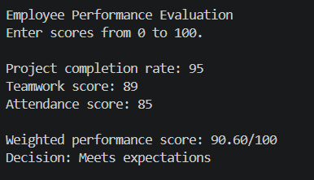
#q5
Task:Use an AI tool to generate a user feedback form application. Review whether the language and options provided are inclusive and accessible to diverse users.
Prompt: generate a python code for a user feedback form application. Review whether the language and options provided are inclusive and accessible to diverse users.
Code:
from dataclasses import asdict, dataclass
import json
from pathlib import Path
OUTPUT_FILE = Path("feedback_submissions.json")
RATING_LABELS = {
"1": "Very dissatisfied",
"2": "Dissatisfied",
"3": "Neither satisfied nor dissatisfied",
"4": "Satisfied",
"5": "Very satisfied",
}
@dataclass
class Feedback:
"""The minimum information needed to understand a user's experience."""
name: str
rating: int
helpful_part: str
improvement: str
contact_permission: bool
contact_details: str
accessibility_needs: str
def ask_required(prompt: str) -> str:
"""Ask until the user provides a non-empty answer."""
while True:
answer = input(prompt).strip()
if answer:
return answer
print("Please enter a response, or type 'skip' if this question is optional.")
def ask_optional(prompt: str) -> str:
"""Return an empty string when an optional question is skipped."""
answer = input(prompt).strip()
return "" if answer.lower() in {"skip", "prefer not to say", "n/a"} else answer
def ask_rating() -> int:
"""Collect a five-point rating with text labels, not just numbers."""
print("\nHow satisfied are you with your experience?")
for number, label in RATING_LABELS.items():
print(f" {number}. {label}")
while True:
answer = input("Choose 1-5: ").strip()
if answer in RATING_LABELS:
return int(answer)
print("Please choose a number from 1 to 5.")
def ask_yes_no(prompt: str) -> bool:
"""Ask a yes/no question without assuming consent."""
while True:
answer = input(f"{prompt} [y/n]: ").strip().lower()
if answer in {"y", "yes"}:
return True
if answer in {"n", "no", "skip", "prefer not to say"}:
return False
print("Please enter y or n.")
def collect_feedback() -> Feedback:
"""Collect feedback while keeping identity and demographic questions optional."""
print("\nUser Feedback Form")
print("Your name and contact details are optional. You may type 'skip' at any optional question.")
name = ask_optional("Name (optional): ")
rating = ask_rating()
helpful_part = ask_required("What worked well? ")
improvement = ask_required("What could we improve? ")
accessibility_needs = ask_optional(
"Is there anything we could change to make this experience more accessible? (optional): "
)
contact_permission = ask_yes_no("May we contact you about this feedback?")
contact_details = ""
if contact_permission:
contact_details = ask_required("Preferred contact method or details: ")
return Feedback(
name=name,
rating=rating,
helpful_part=helpful_part,
improvement=improvement,
contact_permission=contact_permission,
contact_details=contact_details,
accessibility_needs=accessibility_needs,
)
def save_feedback(feedback: Feedback, output_file: Path = OUTPUT_FILE) -> None:
"""Append one submission to a local JSON file."""
submissions = []
if output_file.exists():
try:
submissions = json.loads(output_file.read_text(encoding="utf-8"))
except json.JSONDecodeError:
print("Existing feedback file is not valid JSON; starting a new file.")
submissions.append(asdict(feedback))
output_file.write_text(json.dumps(submissions, indent=2), encoding="utf-8")
def main() -> None:
"""Run the form and save the submission."""
feedback = collect_feedback()
save_feedback(feedback)
print(f"\nThank you for sharing your feedback. It was saved to {OUTPUT_FILE}.")
if __name__ == "__main__":
main()
output:
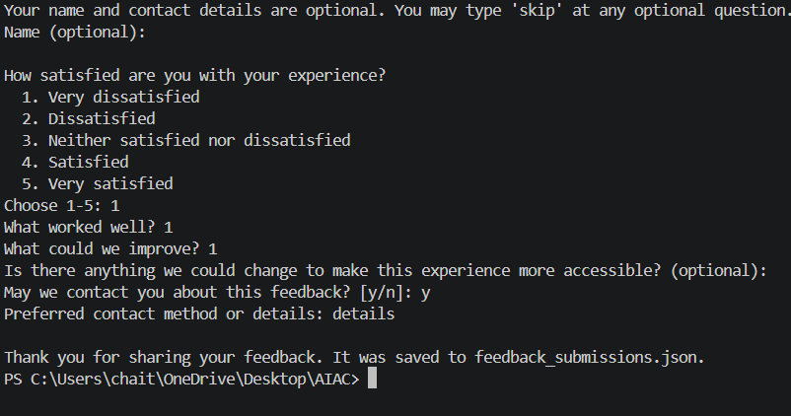
#q6
Task: Use an AI tool to generate a Python program that predicts whether a person should be approved or rejected for a loan based on information such as income, age, employment status, credit score, and loan amount.
Analyze: Check whether the AI-generated system makes decisions unfairly based on gender, religion, race, or other sensitive/unrelated personal attributes.
Prompt: generate a Python program that predicts whether a person should be approved or rejected for a loan based on information such as income, age, employment status, credit score, and loan amount.
Code:
MIN_AGE = 18
MIN_INCOME = 20_000.0
MIN_CREDIT_SCORE = 650
MAX_LOAN_TO_INCOME_RATIO = 3.0
EMPLOYED_STATUSES = {"employed", "self-employed"}
def predict_loan(
age: int,
income: float,
employment_status: str,
credit_score: int,
loan_amount: float,
) -> tuple[str, list[str]]:
"""Return a loan decision and the reasons supporting it."""
if age < 0:
raise ValueError("age cannot be negative")
if income < 0 or loan_amount < 0:
raise ValueError("income and loan amount cannot be negative")
if not 300 <= credit_score <= 850:
raise ValueError("credit score must be between 300 and 850")
status = employment_status.strip().lower()
reasons = []
if age < MIN_AGE:
reasons.append(f"applicant must be at least {MIN_AGE} years old")
if income < MIN_INCOME:
reasons.append(f"income must be at least ${MIN_INCOME:,.0f}")
if status not in EMPLOYED_STATUSES:
reasons.append("applicant must be employed or self-employed")
if credit_score < MIN_CREDIT_SCORE:
reasons.append(f"credit score must be at least {MIN_CREDIT_SCORE}")
if income == 0 or loan_amount > income * MAX_LOAN_TO_INCOME_RATIO:
reasons.append(
f"loan amount must not exceed {MAX_LOAN_TO_INCOME_RATIO:g} times annual income"
)
return ("Approved" if not reasons else "Rejected"), reasons
def read_number(prompt: str, number_type: type[int] | type[float]) -> int | float:
"""Read a non-negative integer or decimal number from the command line."""
while True:
try:
value = number_type(input(prompt))
if value >= 0:
return value
except ValueError:
pass
print("Please enter a non-negative number.")
def main() -> None:
print("Loan Approval Predictor")
print("Enter the applicant's information.\n")
age = read_number("Age: ", int)
income = read_number("Annual income: ", float)
employment_status = input("Employment status: ")
credit_score = read_number("Credit score (300-850): ", int)
loan_amount = read_number("Loan amount: ", float)
try:
decision, reasons = predict_loan(
int(age), income, employment_status, int(credit_score), loan_amount
)
except ValueError as error:
print(f"\nInvalid application: {error}")
return
print(f"\nDecision: {decision}")
if reasons:
print("Reasons:")
for reason in reasons:
print(f"- {reason}")
if __name__ == "__main__":
main()
output:
